**Lab Task:**

#### **Lab Task#1:**

For the Boolean function do the following:



Draw logic circuit diagram in the space provided below and implement the circuit on logic trainer.

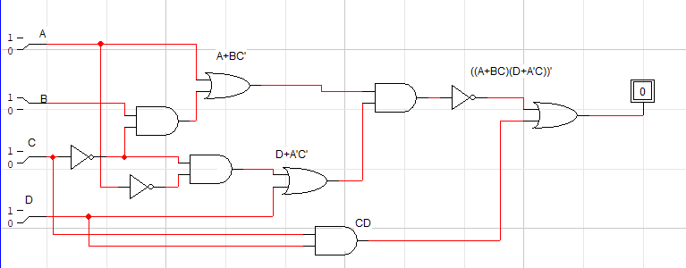

Draw timing diagrams for construction and verification of the circuit

|  |  |  |
| --- | --- | --- |
| Inputs | A |  |
| B |  |
| C |  |
| D |  |
| Output | F1(expected result) |  |
| F1(implementation  result) |  |

**Lab Task#2:** For the Boolean function do the following:



Draw logic circuit diagram in the space provided below and implement the circuit on logic trainer.

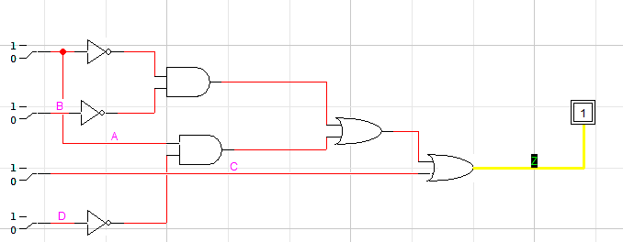

Draw timing diagrams for construction and verification of the circuit

|  |  |  |
| --- | --- | --- |
| Inputs | A |  |
| B |  |
| C |  |
|  | D |  |
| Output | F2(expected result) |  |
| F2(implementation  result) |  |

#### **Lab Task#3:**



Write the Boolean expression for the logic circuit in Figure 12. Also implement the given circuits on breadboard and draw Truth tables:

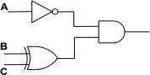

Figure 12: Combinational Circuit

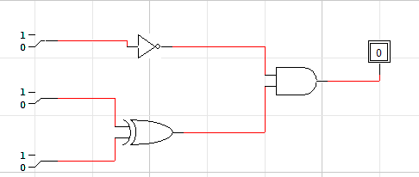

|  |  |  |  |
| --- | --- | --- | --- |
| **A** | **B** | **C** | **D** |
| **0** | **0** | **0** | **0** |
| **0** | **0** | **1** | **1** |
| **0** | **1** | **0** | **1** |
| **0** | **1** | **1** | **0** |
| **1** | **0** | **0** | **0** |
| **1** | **0** | **1** | **0** |
| **1** | **1** | **0** | **0** |
| **1** | **1** | **1** | **0** |

**Task 4:**

Prove that the circuits are equal via the laws mentioned above and via the logic trainer. Make sure to only create both circuits.

1. **A + AB = A**

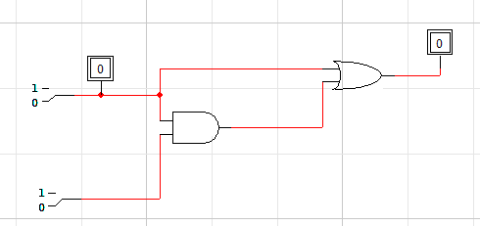

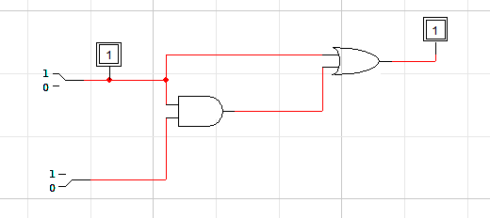

1. **A + ĀB = A + B**

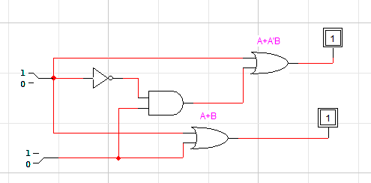

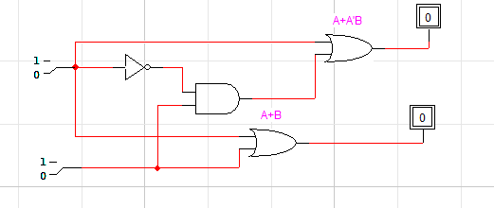

1. **(A + B) (A + C) = A + BC**

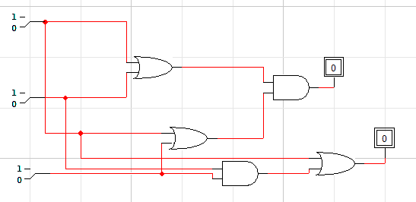

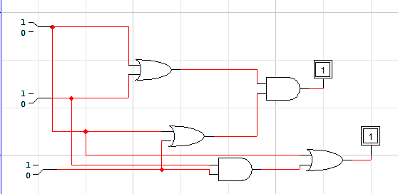

1. **A ⊙ (A ⊙ B) = B**

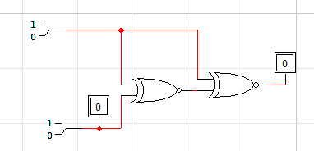

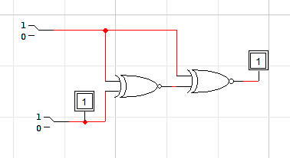

**Task 5:**

Implement the mentioned logic using only two XOR gates.

